Tie On Masks
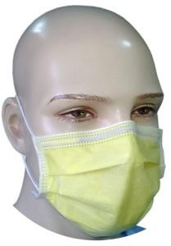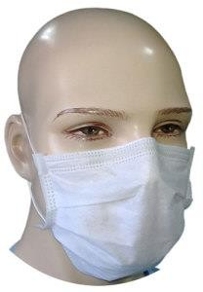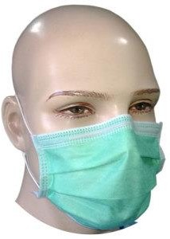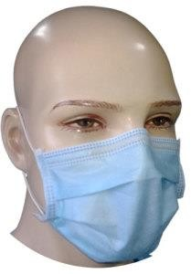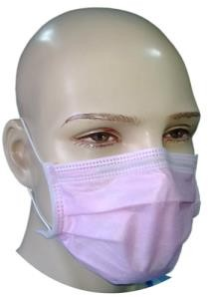
Specifications

- Available in 1/2/3/4-Ply
- Available in Blue/Green/White/Pink/Yellow/Cartoon Print
- Latex Free Round Lycra Elastic. 7.5’’: Elongation 1:2.
- Inside Elastic Sealing for comfort and neater packing
- Easier and quicker to wear than tie-on masks
- International Mask Size: 175 mm x 95 mm
- 10 mm PP Side Banding provides strong elastic attachment
- Malleable PVC/PE coated aluminium nose-clip prevents air leakage
- Test Reports from Nelson Labs (USA) & SITRA India for independent verification
- High Bacteria/Particle/Viral Filtration Levels (> 95% , > 98%)
- Low Breathing Resistance (Delta P < 29, 4 Pa)
- Fluid Repellent Masks available (4-Ply:Splash Resistance > 120 mmHg)
- 3-Ply adheres to European Class EN 14683 Type I & II, CE marked.
- 4-Ply adheres to European Class EN 14683 Type II R, CE marked.
- Packing in PP Bags or Duplex Dispensers
- OEM Facility Available on Bulk Orders

Ear Loop Masks
Specifications

- Available in 1/2/3/4-Ply
- Available in Blue/Green/White/Pink/Yellow/Cartoon Print
- Latex Free Round Lycra Elastic. 7.5’’: Elongation 1:2.
- Inside Elastic Sealing for comfort and neater packing
- Easier and quicker to wear than tie-on masks
- International Mask Size: 175 mm x 95 mm
- 10 mm PP Side Banding provides strong elastic attachment
- Malleable PVC/PE coated aluminium nose-clip prevents air leakage
- Test Reports from Nelson Labs (USA) & SITRA India for independent verification
- High Bacteria/Particle/Viral Filtration Levels (> 95% , > 98%)
- Low Breathing Resistance (Delta P < 29, 4 Pa)
- Fluid Repellent Masks available (4-Ply:Splash Resistance > 120 mmHg)
- 3-Ply adheres to European Class EN 14683 Type I & II, CE marked.
- 4-Ply adheres to European Class EN 14683 Type II R, CE marked.
- Packing in PP Bags or Duplex Dispensers
- OEM Facility Available on Bulk Orders

Childrens’ / Ladies’ Masks

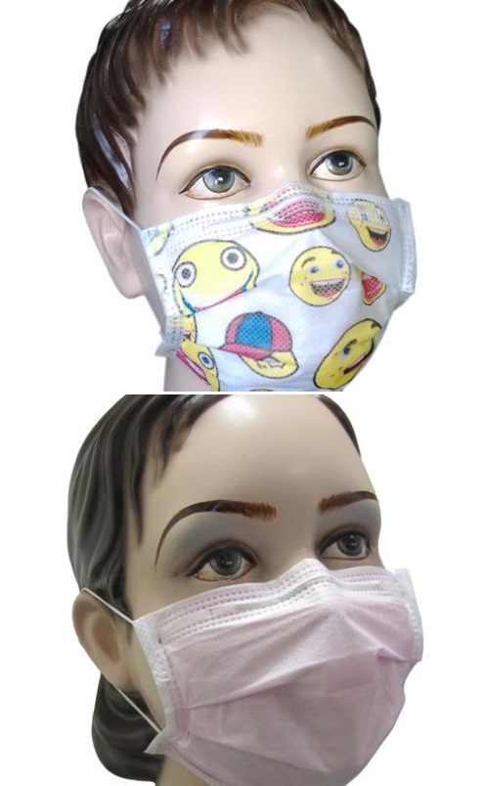
Specifications

- Small sized surgical masks for both children and ladies.
- Surgical mask size 145 x 95 mm to fit petite face sizes of children and ladies
- Product specifications and test parameters identical to the standard adult surgical masks
- Available in cartoon smiley print, baby pink, and with activated carbon for anti pollution masks.

N95 Particulate Respirators

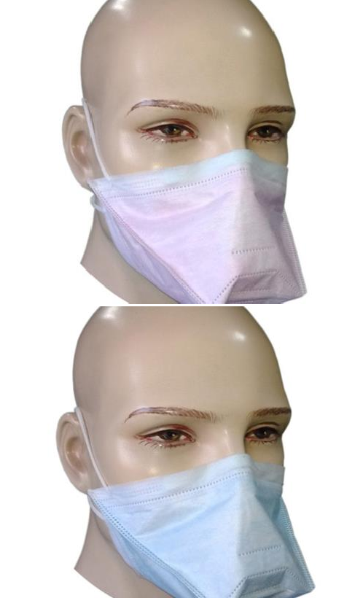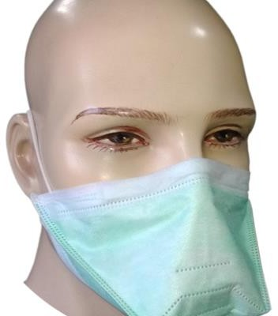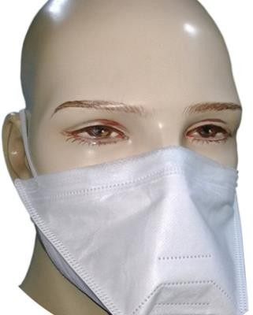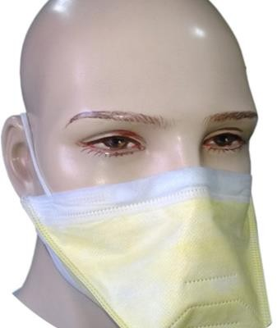Specifications

- Exceeds test requirements of Title 42, Code of Federal Regulations, Part 84 (42 CFR 84)
- Meets performance criteria recommended by CDC for respiratory devices used in healthcare settings for protection against Mycobacterium tuberculosis (MTB), the infectious agent that causes tuberculosis (TB).
- Particulates for which these respirators provide protection include contaminants such as dusts, fumes, mists and smoke.
- N Series respirators are intended for use in those workplaces free of oil aerosols

Specific Performance Features

- Filter Efficiency > 95% against 0.26 µm NaCl Aerosol airflow at 85 Litres/Minute
- Average Maximum % Leakage of 2.5% (Nelson Lab Ref No. 505482)
- Inhalation Resistance average of 9.4 mm H2O (Nelson Lab Ref No. 505482)
- Exhalation Resistance average of 12.6 mm H2O (Nelson Lab Ref No. 505482)

Product Features - Production Technology

- 100% ultrasonically machine manufactured without manual intervention
- Cost efficiencies through automation
- Higher quality product finishing
- Hygienic automated production processes

Unique Duck Bill Design

- Ergonomic design permits perfect fit on any face shape
- Minimal face contact more comfortable and less irritation
- Large breathing chamber allows longer use, more comfort and better performance by the user
- Excellent inhalation/exhalation performance eliminates requirement for valve and therefore potentially dangerous valve leakage
- Enhanced visibility for users wearing goggles/specs

